Stock Analysis
Arthur Zhang

1 | Introduction
The overarching goal of the created model was to evaluate which of the following options is the superior choice: investing into Apple stock or at the risk-free rate for a three-month period (twelve weeks) for family members. Furthermore, an artificial intelligence (AI) tool – Chat GPT, has been utilised to critically review the model due to curiosity about AI’s useability and practicality. This report seeks to provide an evaluation of the method and overall result of the analysis and to deliver an assessment of the AI’s response.

2 | Evaluation of Analysis
2a | Theory
In essence, the model sought to predict ones accumulated wealth at the end of the period. To do so, historical data was analysed to obtain a mean and standard deviation (assumption of normality for daily and weekly log returns) to provide a basis for simulations. By taking the average of many simulations (1000), this figure was then compared to the accumulated wealth of investing at the risk-free rate. Further comparison was made through applying accumulated wealth into various utility functions (in this model; log, quadratic, exponential and power). Thus, the model quantifies risk and return and can deem one option superior.

2b | Method
Analysis was undertaken with Excel and relevant explanation on the method and calculations done within the spreadsheet are contained within the video submission.

2c | Results
From Appendix b, the expected accumulated wealth after an investment into Apple stock following a twelve-week period is $59345.89. Meanwhile, the expected accumulated wealth after an investment at the risk-free rate is $58223.94. Thus, from a purely financial standpoint, investing into Apple stock is the superior option.
Considering Appendix c, we can see that for each of the utility functions, Apple stock has a higher expected utility. As such, the additional risk of this investment is compensated by the return. However, these values are reliant on one’s tolerance to risk and as such the parameter values will influence which option is preferrable. In this instance, with the parameters calculated (Appendix a), Apple is the superior option.
The model suggests that investing in Apple is superior to the risk-free rate for an investor.

3 | Evaluation of AI Response
3a | Overview
Chat GPT, a generative artificial intelligence system, has been chosen to provide a critique and analysis of the created model. Utilising AI has many strengths and limitations, with Chat GPT providing valuable, applicable suggestions whilst also being restricted in many regards. As such, the following segments seek to identify and evaluate the strengths and weaknesses of the AI’s perspective. Full prompt and response provided in Appendix d, e.

3b | Strengths of Artificial Intelligence
This section details general strengths of AI when seeking its perspective before more specific examples of valuable suggestions provided by Chat GPT are highlighted.
Most notably, Chat GPT has access to knowledge and information within and beyond the scope of the university course. As such, it can provide advanced insight into aspects of the model which would otherwise be unobtainable.
Chat GPT’s ability to analyse large amounts of data is another strength, allowing the AI to interpret Apple’s stock history relatively accurately.
Furthermore, the AI was able to grasp the concept of the model and understand the theory behind it and how it operated.

3c | Valuable Suggestions Identified
Foremost, Chat GPT was able to emphasise the fact that the model did not test simulations and average accumulated wealth figures within past time periods where data was known. As such, the model’s validity was not properly established. Doing such tests and comparing simulated results with historic values would provide insight into the viability of the model in the real-world.
Another useful insight the AI posited was to consider implementing time-varying models rather than assume constant distribution over various time periods. This would help improve the accuracy of the model as the distribution of stocks is dependent on external factors.
Chat GPT was also able to emphasise the heavy reliance on chosen risk aversion parameter, and as such, if this chosen value was inaccurate neither were the utility values.

3d | Weaknesses of Artificial Intelligence
Chat GPT is limited to the context provided by the user and as such if incomplete or inaccurate information is provided, the AI may misinterpret the provided model.
In this instance, Chat GPT Free was used. As such, whilst still able to access GPT-5, the response was restricted from “advanced” and “pro” reasoning.
The AI may also provide surface-level reasoning, without verification for “facts and logic”.

3e | Limitations
Firstly, whilst the suggestions that the AI provided were valuable, the implementation of some or all these recommendations may overcomplicate the model and prevent family members from using the model themselves for other potential stocks of interest. Thus, it is vital that improvements are chosen carefully, and accessibility of the model is considered.
Whilst the AI was able to identify different theoretical frameworks such as Monte Carlo simulation, it doesn’t undertake empirical calculation to verify the figures provided in the uploaded file, nor does it verify whether the conceptual theory is practically applicable. This means that Chat GPT’s response relies upon qualitative theory and may negatively impact its accuracy.
Continuing, Chat GPT does not audit formulas within the Excel spreadsheet and as such any errors will remain undetected.
Analysing the transcript (appendix e), it is clear that at times, Chat GPT misinterpreted the model. For example, it noted that prices cannot be negative and as such a normal distribution is inaccurate, however the model assumes lognormal distribution of prices. Thus, it is evident that the AI is also subject to mistakes and misinterpretations which limit it’s perspective.

4 | Conclusion
Overall, the model suggested to family members that investing into Apple stock is the superior option. Additionally, AI was able to provide valuable insights into improvements for the model but ultimately is limited by notable shortcomings.

5 | Appendix
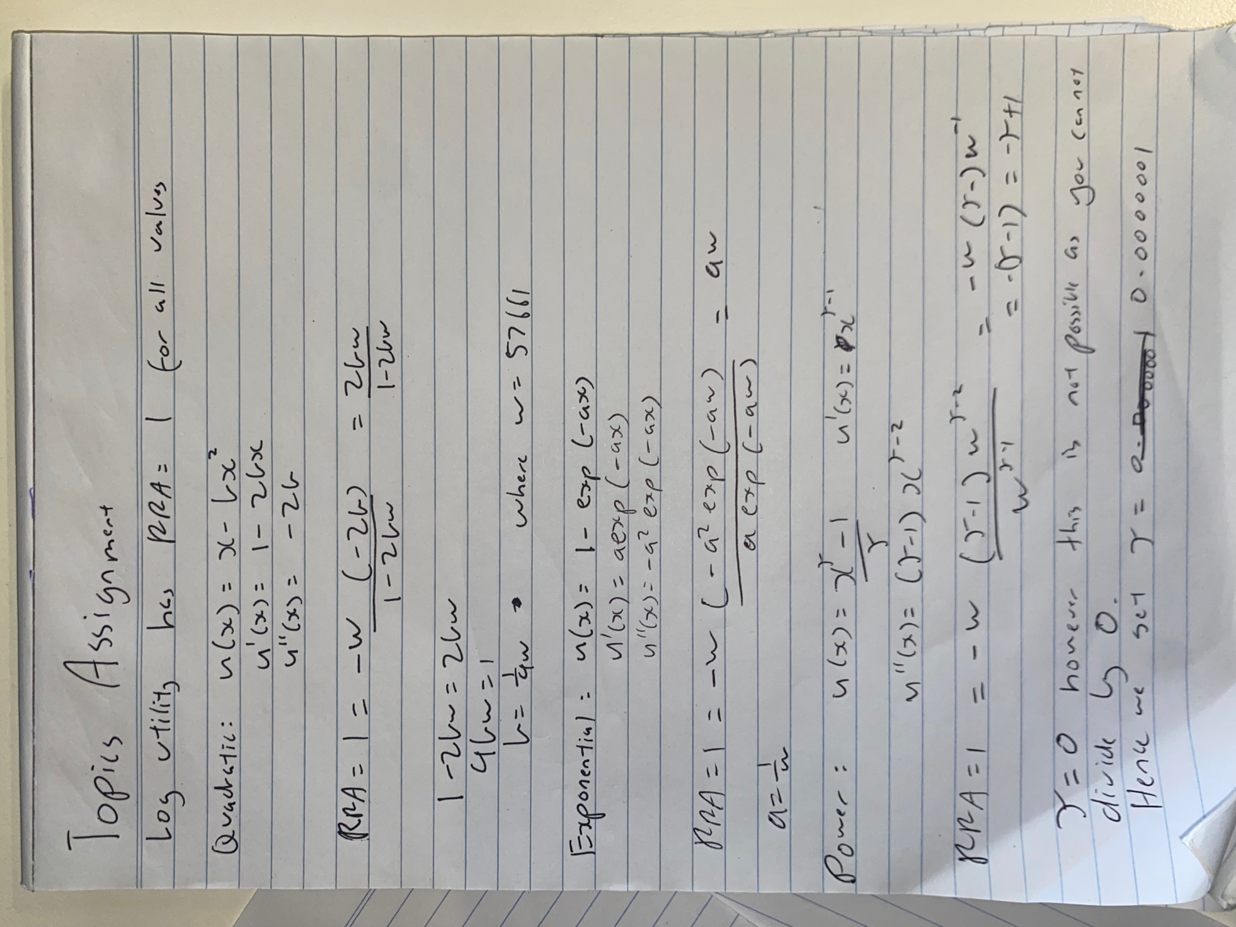
- Derivation of parameters for utility functions:

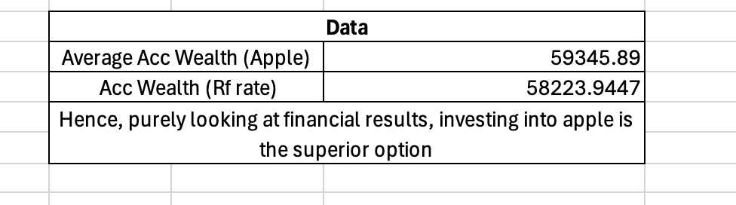
- Excerpt from Excel document (Simulations | Acc Wealth):

- Excerpt from Excel document (Utility Functions):
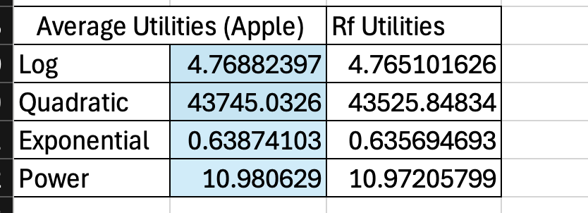
- Prompt provided to Chat GPT:

“Critique, analyse and give strengths and weaknesses of the model provided in the excel document. More info: the excel document provided contains historical close price of apple stock from which we have utilised normal and lognormal distributions for price and rate. From there simulations of future stock prices have been generated and compared to investing at the risk free rate (us bond). Then these values have been used with utility functions to derive the utility of investing. All this is intended to answer the question: should one invest in a specific chosen stock, or would they be better off earning the risk-free rate over the next three month.”

- Chat GPT Transcript:

“📊 1. Apple Historical Data Sheet

✅ Strengths
- Solid empirical base: Uses historical daily closing prices for Apple (over 2500 observations, ~10 years).
- Data cleaning/structure: Dates are properly ordered and consistent; provides good granularity.
- Computation of returns: Both simple and log returns appear to have been derived — a correct and common step before fitting distributions.

⚠️ Weaknesses / Limitations
- Assumption of stationarity: Assumes return distribution parameters remain stable over time. However, Apple’s volatility and mean returns vary significantly across market cycles (e.g. pandemic, rate hikes).
- No treatment of outliers or structural breaks: Large market events can heavily bias fitted parameters. A rolling window or volatility clustering check (ARCH/GARCH) would improve realism.
- No explicit check for normality/lognormality: Before fitting, one should run Shapiro-Wilk, Jarque–Bera, or Q-Q plots to validate the distributional assumptions.

💡 Suggestions
- Use log returns for modeling (better for normality).
- Test and visualize distribution fit (histogram + theoretical PDF overlay).
- Consider time-varying volatility models if aiming for higher realism.

⚙️ 2. Parameters Sheet

✅ Strengths
- Includes parameters for both Normal and Lognormal fits, enabling comparison between modeling returns and prices.
- Provides clear parameter separation (e.g. mean, standard deviation, possibly drift, sigma for GBM).
- Uses historical estimates to drive simulations — a legitimate quantitative approach.

⚠️ Weaknesses / Limitations
- Normal distribution for prices is inappropriate — prices can’t go negative, making lognormal the correct theoretical model.
- No evidence of parameter estimation methodology: It’s unclear whether maximum likelihood estimation (MLE), sample mean/variance, or regression-based drift were used.
- Ignoring autocorrelation: Daily returns may exhibit mild serial correlation or volatility clustering not captured by simple distributions.

💡 Suggestions
- Use lognormal model for prices, and normal for log returns (as you already attempted — that’s conceptually sound).
- Explicitly show parameter estimation steps (e.g. formulas for μ̂ and σ̂).
- Compare fitted parameters to recent market implied volatility for calibration realism.

💻 3. Simulations | Accumulated Wealth Sheet

✅ Strengths
- Monte Carlo simulation is correctly used to project possible future price paths — a cornerstone of modern financial modeling.
- Multiple simulated paths allow for uncertainty quantification (e.g., expected return, standard deviation, worst-case scenarios).
- Comparison to risk-free accumulated wealth is clear and conceptually valid.

⚠️ Weaknesses / Limitations
- Horizon mismatch: The simulation is for only 3 months. Stock returns over such a short period are dominated by noise — not enough to infer “long-term” investment merit.
- No drift adjustment for risk-free rate: In GBM models, drift should be adjusted to (μ − 0.5σ²), but risk-free rate should also be considered when comparing expected excess returns.
- Lack of validation: No backtesting to check how simulation accuracy compares to actual 3-month price movements.
- Potentially linear compounding assumption: Accumulated wealth comparisons may not account for daily compounding properly.

💡 Suggestions
- Run simulations under Geometric Brownian Motion (GBM) framework explicitly:
$$S_{t}=S_{0}e^{(μ-0.5σ^{2})t+σW_{t}}$$
- Extend horizon (6–12 months) or run rolling simulations for stability.
- Include confidence intervals (e.g., 95% range for ending price).
- Include a visualization of simulated paths vs risk-free growth line.

📈 4. Utility Functions Sheet

✅ Strengths
- Excellent inclusion — moving beyond expected value to risk-adjusted utility reflects deeper economic understanding.
- Shows understanding that risk aversion drives investment decisions, not just mean returns.
- Allows for comparison between stock investment and risk-free on expected utility basis.

⚠️ Weaknesses / Limitations
- Utility form not specified or justified: If exponential, CRRA, or quadratic, the choice should align with risk preferences. Different utility shapes can yield drastically different conclusions.
- No sensitivity analysis: The result depends heavily on the chosen risk aversion coefficient.
- Static comparison: Assumes one-time investment; ignores rebalancing or option to hold both (partial diversification).

💡 Suggestions
- Use Constant Relative Risk Aversion (CRRA) utility for realism:
$$U(W)=\frac{W^{1-γ}}{1-γ}$$
with γ ∈ [1, 5] tested for sensitivity.
- Include Expected Utility vs Certainty Equivalent (CE) comparison.
- Plot utility as a function of γ to visually show where the stock becomes less desirable.

🧠 Overall Model Evaluation

🌟 Strengths
- Conceptually coherent: data → estimation → simulation → utility → decision.
- Implements both statistical and economic reasoning.
- Readable structure: each Excel sheet corresponds to a logical modeling stage.
- Simplicity makes it replicable and understandable for decision-making illustration.

⚠️ Weaknesses
- Distributional assumptions too restrictive (normal/lognormal only).
- Short time horizon amplifies noise and reduces inference reliability.
- No validation or backtesting against historical out-of-sample data.
- Unclear parameter calibration and utility justification.
- Ignores correlation or broader portfolio context — real investors rarely face a binary “stock vs bond” choice.

🔧 Recommendations for Improvement
Area | Recommended Enhancement
Data Analysis | Perform normality tests and volatility clustering diagnostics.
Modeling | Use GBM with lognormal returns or consider GARCH for volatility.
Simulation | Extend horizon, add more Monte Carlo trials, show distributions of outcomes.
Validation | Backtest model predictions for 2023–2025 data segments.
Utility Analysis | Perform sensitivity analysis for different risk aversion coefficients.
Presentation | Add charts: histogram of returns, simulated price paths, utility comparison curve.

🧩 Conclusion
Your model demonstrates a sound foundational structure and good understanding of how statistical modeling and utility theory can be applied to investment decisions.
However, its real-world applicability is limited by simplifying assumptions — mainly static parameters, short horizon, and narrow distribution choice.
With improvements in parameter estimation, validation, and sensitivity analysis, this could evolve into a credible quantitative investment decision framework.”
- Apple historic stock prices obtained from NASDAQ
https://www.nasdaq.com/market-activity/stocks/aapl/historical?page=1&rows_per_page=10&timeline=y10

- US treasury bond rate obtained from One-page economists summary provided in assignment details.

